<!DOCTYPE html>

<html lang="en">

<head>

    <meta charset="UTF-8">

    <meta http-equiv="X-UA-Compatible" content="IE=edge">

    <meta name="viewport" content="width=device-width, initial-scale=1.0">

    <meta name="description" content="KassyCafe">

    <!-- Google fonts Connect CDN-->

    <link rel="preconnect" href="https://fonts.googleapis.com">

    <link rel="preconnect" href="https://fonts.gstatic.com" crossorigin>

    <!-- Google fonts -->

    <link href="https://fonts.googleapis.com/css2?family=Heebo:wght@400;900&display=swap" rel="stylesheet">

    <link href="https://fonts.googleapis.com/css2?family=Titillium+Web:wght@300&display=swap" rel="stylesheet">

    <!-- font icons -->

    <link rel="stylesheet" href="https://cdnjs.cloudflare.com/ajax/libs/font-awesome/5.15.3/css/all.min.css" integrity="sha512-iBBXm8fW90+nuLcSKlbmrPcLa0OT92xO1BIsZ+ywDWZCvqsWgccV3gFoRBv0z+8dLJgyAHIhR35VZc2oM/gI1w==" crossorigin="anonymous" referrerpolicy="no-referrer" />

    <!-- CSS Link -->

    <link rel="stylesheet" href="css/main.css" type="text/css">

    <title>KassyCafe</title>

</head>

<body>

    <!-- Nav bar -->

    <div class="nav first-font">

        <a href="#"> <img src="icon/klassy.ico" alt="logo"></a>

        <a href="#" id="home">Home</a>

        <a href="#">About</a>

        <a href="#" >Menu</a>

        <a href="#">Chefs</a>

        <a href="#">Features</a>

        <a href="#">Contact Us</a>

    </div>

    <!-- Main Function-->

    <div class="main">

        <!-- First Main Top-->

        <div class="top-main">

            <div class="left1">

                <div class="left1-text">

                <span style="font-family: Brush Script MT; font-size: 80px; color: white;">KassyCafe</span>

                <br>

                <span class="first-font" style="color: white;">THE BEST EXPERIENCE</span>

                <br>

                <br>

                <button id="reservation">Make A Reservation</button>

                </div>

            </div>

            <div class="right1">

                <img src="image/resturant1.jpg" alt="resturant" width="100%">

            </div>

        </div>

        <!-- About Us Main Middle-->

        <div class="mid-main">

            <div class="left2">

                <div class="left-content" style="margin-right: 5%;">

                <hr> <span class="first-font" style="color: #fb6358;">ABOUT US</span>

                <p class="second-font">We Leave A Delicious <br> Memory For You </p>

                <p>Klassy Cafe is one of the best resturant HTML templates with Bootstrap v4.52 CSS Framework. you can Download and feel free to use this website emplate layout forr your resturant business.Ypu are allowed to use this template for commercial purposes</p>

                <br>

                <p>You are NOT  allowed to redistribute the template ZIP file on any template download website. Please Contact us for mroe information</p>

                    <div class="images-left" style="margin-top: 50px;">

                    <img src="image/shuhsi.jpg" alt="sushi" width="200px" style="margin-right: 20px;">

                    <img src="image/chicken.jpg" alt="chiken" width="200px" style="margin-right: 20px;">

                    <img src="image/thai.jpg" alt="thai" width="200px" style="margin-right: 20px;">

                    </div>

                </div>

            </div>

            <div class="right2">

                <iframe width="100%" height="100%" src="https://www.youtube.com/embed/Ax8zuvqV1Ik" poster="image/resturant.jpg" width="60%" controls style="margin-left: 10%; border: none; border-radius: 8px;">

                </iframe>

            </div>

        </div>

        <!-- Menu Main -->

        <div class="menu-main">

            <div class="heading-menu">

                <hr> <span class="first-font" style="color: #fb6358;">OUR MENU</span>

                <p class="second-font">Our Selection of cakes <br> with quality taste </p>

            </div>

            <div class="menu">

                <div class="cake-cards">

                    <img src="image/cake3.jpg" alt="redVelvet" style="grid-column: 1 / 2; grid-row: 1 / -4; border-radius: 8px 5px 8px 8px;" width="300px">

                    <span class="padding-font menu-style" id="padding1" style=" grid-row: 4 / -2; grid-column: 1 / 2; text-align: center; border-radius: 0 0 8px 8px;">Red Velvet Cake</span>

                    <span class="padding-font menu-style " style=" grid-row: 1 / -4; grid-column: 1 / 2; margin-right: 230px; text-align: center;">$8.50</span>

                </div>

                <div class="cake-card2">

                   <img src="image/cake.jpg" alt="redVelvet" style="grid-column: 1 / 2; grid-row: 1 / -4; border-radius: 8px 5px 8px 8px;" width="300px" height="400px">

                    <span class="padding-font menu-style" id="padding1" style=" grid-row: 4 / -2; grid-column: 1 / 2; text-align: center; border-radius: 0 0 8px 8px;">Kassy Cup Cake</span>

                    <span class="padding-font menu-style " style=" grid-row: 1 / -4; grid-column: 1 / 2; margin-right: 230px; text-align: center;">$7.25</span>

                </div>

                <div class="cake-card3">

                    <img src="image/cake2.jpg" alt="redVelvet" style="grid-column: 1 / 2; grid-row: 1 / -4; border-radius: 8px 5px 8px 8px;" width="300px" height="400px">

                     <span class="padding-font menu-style" id="padding1" style=" grid-row: 4 / -2; grid-column: 1 / 2; text-align: center; border-radius: 0 0 8px 8px;">Big Wedding Cake</span>

                     <span class="padding-font menu-style " style=" grid-row: 1 / -4; grid-column: 1 / 2; margin-right: 230px; text-align: center;">$25</span>

                 </div>

                 <div class="cake-card4">

                    <img src="image/cake4.jpg" alt="redVelvet" style="grid-column: 1 / 2; grid-row: 1 / -4; border-radius: 8px 5px 8px 8px;" width="300px" height="400px">

                     <span class="padding-font menu-style" id="padding1" style=" grid-row: 4 / -2; grid-column: 1 / 2; text-align: center; border-radius: 0 0 8px 8px;">Fruit Berries Cake</span>

                     <span class="padding-font menu-style " style=" grid-row: 1 / -4; grid-column: 1 / 2; margin-right: 230px; text-align: center;">$10.35</span>

                 </div>

                 <div class="cake-card5">

                    <img src="image/cake5.jpg" alt="redVelvet" style="grid-column: 1 / 2; grid-row: 1 / -4; border-radius: 8px 5px 8px 8px;" width="300px" height="400px">

                     <span class="padding-font menu-style" id="padding1" style=" grid-row: 4 / -2; grid-column: 1 / 2; text-align: center; border-radius: 0 0 8px 8px;">Strawberry Pan Cake</span>

                     <span class="padding-font menu-style " style=" grid-row: 1 / -4; grid-column: 1 / 2; margin-right: 230px; text-align: center;">$5</span>

                 </div>

            </div>

            </div>

        </div>

        <!-- Chef Main Middle -->

        <div class="chef-main" style="margin-bottom: 6%;">

            <div class="heading-chef" style="text-align: center; margin-top: 5%; margin-bottom: 5%;">

                 <span class="first-font" style="color: #fb6358;">OUR CHEFS</span>

                <p class="second-font">We offer The Best <br>ingredients for you </p>

            </div>

            <div class="chefs">

                <div class="chef-card1">

                    <img src="image/chef1.jpg" alt="chef 1" width="350px" height="350px" style="border-radius: 4px;">

                    <span class="padding-font chef-name" style="grid-row: 2 / -2; padding: 20px;"> Randy Walker</span>

                    <span style="grid-row: 3 / 4;"> Pastry Chef</span>

                </div>

                <div class="chef-card2">

                    <img src="image/chef2.jpg" alt="chef 1" width="350px" height="350px" style="border-radius: 4px;">

                    <span class="padding-font chef-name" style="grid-row: 2 / -2; padding: 20px;"> David Martin</span>

                    <span style="grid-row: 3 / 4;"> Cookie Chef</span>

                </div>

                <div class="chef-card3">

                    <img src="image/chef3.jpg" alt="chef 1" width="350px" height="350px" style="border-radius: 4px;">

                    <span class="padding-font chef-name" style="grid-row: 2 / -2; padding: 20px;"> Kelly Perkson</span>

                    <span style="grid-row: 3 / 4;"> Pancake Chef</span>

                </div>

            </div>

        </div>

        <!-- Reservation Main  -->

            <div class="reservation">

                <div class="left-reservation" style="color: white; margin-top: 10%;">

                    <hr style="border-color: white;"> <span class="first-font" style="color: white;">ABOUT US</span>

                    <br>

                    <br>

                    <span class="second-font" style="color:whitesmoke;">Here You can Make A Reservation <br> Or Just walk in to our cafe</span>

                    <br>

                    <br>

                    <br>

                    <br>

                    <span style="font-size: 20px;">Donec pretium est orci, non vulputate arcu hendrerit a,fusce a eleifend <br> riqsie, namei sollictudin urna diam, sed commodo purus porta ut.</span>

                    <div class="trial">

                    <div class="left-phonenumber" style="padding: 0 30px 30px 30px; background-color: white; border-radius: 10px; width: 30%; text-align: center; margin-top: 50px; margin-right: 20px;">

                        <i class="fa fa-phone" aria-hidden="true" style="padding: 25px; background-color: tomato; border-radius: 50%; font-size: 25px; margin-top: -70px;"></i>

                        <br>

                        <span class="second-font">Phone Number</span>

                        <br>

                        <span style="color: black;">080-090-0990</span>

                        <br>

                        <span style="color: black;">080-090-0880</span>

                    </div>

                    <div class="right-phonenumber" style="padding: 0 30px 30px 30px; background-color: white; border-radius: 10px; width: 30%; text-align: center; margin-top: 50px; ">

                        <i class="fa fa-envelope" aria-hidden="true" style="padding: 25px; background-color: tomato; border-radius: 50%; font-size: 25px; margin-top: -70px; "></i>

                        <br>

                        <span class="second-font">Email</span>

                        <br>

                        <br>

                        <span style="color: black;">hello@company.com</span>

                        <br>

                        <span style="color: black;">info@company.com</span>

                    </div>

                </div>

                </div>

                <div class="right-reservation">

                    <p class="second-font" style="grid-column: 1 / 6; grid-row: 2 / -7; margin: 0;">Table Reservation</p>

                    <input type="text" name="name" id="res" style="grid-column: 1 / 3; grid-row: 3 / -6;" placeholder="Your Name">

                    <input type="email" name="email" id="res" style="grid-column: 4 / 6; grid-row: 3 / -6;" placeholder="Your Email Adress">

                    <input type="number" name="number" id="res" style="grid-column: 1 / 3; grid-row: 4 / -5;" placeholder="Phone Number">

                    <input type="number" name="guets" id="res" style="grid-column: 4 / 6; grid-row: 4 / -5;" placeholder="Number of Guests">

                    <input type="date" name="date" id="res" style="grid-column: 1 / 3; grid-row: 5 / -4;">

                    <input type="datetime" name="time" id="res" style="grid-column: 4 / 6; grid-row: 5 / -4;" placeholder="Time">

                    <textarea name="textarea" id="res" cols="30" rows="10" style="grid-column: 1 / 6; grid-row: 6 / -3;" placeholder="Message"></textarea>

                    <input type="submit" id="res" class="reservation-button" value="Make a Reservation" style="grid-column: 1 / 6; grid-row: 7 / -2;">

                </div>

                </div>

            </div>

            <!-- Offers Main division -->

            <div class="klassy-week" style="margin-top: 80px; text-align: center;">

                <span class="first-font" style="color: #fb6358;"> KLASSY WEEK</span>

                <br><br>

                <span class="second-font">This Week's Special <br>Meal Offers</span>

                <br><br><br>

                <div class="logos" style="color: #fb6358; font-size: 40px; display: flex; justify-content: center; margin-bottom: 80px;">

                <i class="fas fa-coffee" style="padding: 20px 20px 10px 20px;background-color:#E1E2E4; margin-right: 30px; border-radius: 5px;"> <br> <span style="font-size: 20px;" class="second-font"> Breakfast </i>

                <br>

                <i class="fas fa-hamburger" style="padding: 30px;background-color:#E1E2E4; margin-right: 30px; border-radius: 5px;"><br> <span style="font-size: 20px;" class="second-font"> Lunch </i>

                <i class="fas fa-utensils" style="padding: 20px;background-color:#E1E2E4; border-radius: 5px;"> <br> <span style="font-size: 20px;" class="second-font"> Dinner </i>

                </div>

                <div class="first-offer">

                <div class="week-offer">

                    <img src="image/bow1.jpg" alt="bowl1" style="grid-column: 1 / 2; overflow: hidden; border-radius: 8px;" width="100px">

                    <span style="font-family: 'Heebo', sans-serif; font-weight:600; font-size: 20px; text-align: left; grid-column: 2 /3;"> Fresh Chicken Salad <br> <span style="font-weight: 500; font-size: 20px;"> Lorem ipusm dolor sit amet, consectetur <br> koit adispicing elit , sed do. </span></span>

                    <span class="second-font" style="background-color: #fb6358; color: white; padding-top: 35px; font-size: 30px; border-radius: 8px;"> $10.50</span>

                </div>

                <div class="week-offer2">

                    <img src="image/bow2.jpg" alt="bowl1" style="grid-column: 1 / 2; overflow: hidden; border-radius: 8px;" width="130px">

                    <span style="font-family: 'Heebo', sans-serif; font-weight:600; font-size: 20px; text-align: left; grid-column: 2 /3;"> Veg Sandwhich <br> <span style="font-weight: 500; font-size: 20px;"> Lorem ipusm dolor sit amet, consectetur <br> koit adispicing elit , sed do. </span></span>

                    <span class="second-font" style="background-color: #fb6358; color: white; padding-top: 35px; font-size: 30px; border-radius: 8px;"> $6.50</span>

                </div>

            </div>

            <div class="second-offer">

                <div class="week-offer3">

                    <img src="image/bow3.jpg" alt="bowl1" style="grid-column: 1 / 2; overflow: hidden; border-radius: 8px;" width="135px">

                    <span style="font-family: 'Heebo', sans-serif; font-weight:600; font-size: 20px; text-align: left; grid-column: 2 /3;"> Orange Juice <br> <span style="font-weight: 500; font-size: 20px;"> Lorem ipusm dolor sit amet, consectetur <br> koit adispicing elit , sed do. </span></span>

                    <span class="second-font" style="background-color: #fb6358; color: white; padding-top: 35px; font-size: 30px; border-radius: 8px;"> $8.50</span>

                </div>

                <div class="week-offer4">

                    <img src="image/bow4.jpg" alt="bowl1" style="grid-column: 1 / 2; overflow: hidden; border-radius: 8px;" width="130px">

                    <span style="font-family: 'Heebo', sans-serif; font-weight:600; font-size: 20px; text-align: left; grid-column: 2 /3;"> Tomato soup <br> <span style="font-weight: 500; font-size: 20px;"> Lorem ipusm dolor sit amet, consectetur <br> koit adispicing elit , sed do. </span></span>

                    <span class="second-font" style="background-color: #fb6358; color: white; padding-top: 35px; font-size: 30px; border-radius: 8px;"> $5.00</span>

                </div>

            </div>

            <div class="third-offer">

                <div class="week-offer4">

                    <img src="image/bow5.jpg" alt="bowl1" style="grid-column: 1 / 2; overflow: hidden; border-radius: 8px;" width="110px">

                    <span style="font-family: 'Heebo', sans-serif; font-weight:600; font-size: 20px; text-align: left; grid-column: 2 /3;"> Fruit Salad <br> <span style="font-weight: 500; font-size: 20px;"> Lorem ipusm dolor sit amet, consectetur <br> koit adispicing elit , sed do. </span></span>

                    <span class="second-font" style="background-color: #fb6358; color: white; padding-top: 35px; font-size: 30px; border-radius: 8px;"> $9.90</span>

                </div>

                <div class="week-offer5">

                    <img src="image/bow6.jpg" alt="bowl1" style="grid-column: 1 / 2; overflow: hidden; border-radius: 8px;" width="110px">

                    <span style="font-family: 'Heebo', sans-serif; font-weight:600; font-size: 20px; text-align: left; grid-column: 2 /3;"> Omlette & Cheese <br> <span style="font-weight: 500; font-size: 20px;"> Lorem ipusm dolor sit amet, consectetur <br> koit adispicing elit , sed do. </span></span>

                    <span class="second-font" style="background-color: #fb6358; color: white; padding-top: 35px; font-size: 30px; border-radius: 8px;"> $4.10</span>

                </div>

            </div>

            </div>

            <!-- Footer Divison -->

            <div class="footer">

                <div class="leftside-footer" style="font-size: 25px; padding: 30px 0 10px 0;">

                <i class="fab fa-facebook-f"></i>

                <i class="fab fa-twitter"></i>

                <i class="fab fa-linkedin"></i>

                <i class="fab fa-instagram"></i>

                 </div>

                <div class="mid-footer" style="margin-left: auto;">

                <img src="icon/logo2.ico" alt="logo2" width="170px">

                 </div>

                <div class="end-footer" style="margin-left: auto; color: white; padding: 30px 0 10px 0;">

                <span>&copy; Copyright Klassy Cafe Co. <br> Design Adeeb Shah</span>

                </div>

            </div>

    </div>

</body>

</html>

**Main.css**

/* font-family: 'Titillium Web', sans-serif; */

body{

    box-sizing: border-box;

    font-family: 'Heebo', sans-serif;

}

.nav{

    display: flex;

    margin-right: 5%;

    margin-left: 3%;

    align-items: center;

}

#home{

    margin-left: auto;

}

.first-font{

    font-family: 'Titillium Web', sans-serif;

    font-weight: 800;

    font-size: 20px;

    letter-spacing: 2px;

}

.second-font{

    font-family: 'Heebo', sans-serif;

    font-size: 40px;

    font-weight: 900;

    color: #303132 ;

}

.nav a{

    padding: 30px;

    text-decoration: none;

}

.nav a:visited{

    color: black;

}

.nav a:link{

    color: black;

}

.nav a:hover{

    color:#fb6358;

}

img[alt="logo"]{

    color: white;

    flex-grow: 2;

    width: 170px;

}

.top-main{

    display: flex;

    flex-wrap: wrap;

    align-items: center;

}

.left1{

    flex: 25%;

    background-color: #fb6358;

    padding-top: 17%;

    padding-bottom: 18%;

}

.left1-text{

    flex: 25%;

    margin-left: 50px;

    margin-right: 30px;

}

.right1{

    flex: 75%;

    justify-content: center;

}

#reservation{

    background-color: white;

    border: none;

    color: #fb6358;

    font-family: 'Titillium Web', sans-serif;

    padding: 15px 25px 15px 25px;

    font-size: 20px;

    font-weight: 800;

    border-radius: 8px;

}

hr{

    border: 1px solid #fb6358;

}

.mid-main{

    display: flex;

    flex-wrap: wrap;

    margin: 2% 12% 2% 12%;

 }

 .left2,

 .left-reservation{

     flex: 50%;

 }

 .right2,

 .right-reservation{

     flex: 50%;

 }

 .padding-font{

     font-family: 'Heebo', sans-serif;

     font-size: 20px;

     font-weight: 600;

 }

 .heading-menu{

     margin-left: 10%;

 }

 .menu-main{

    padding-top: 7%;

    padding-bottom: 4%;

    background-color: #EAEDED;

 }

 .menu-style{

    color: white;

    background-color: #fb6358;

    border-radius: 8px;

    padding-top: 20px;

 }

 .cake-cards,

  .cake-card2,

   .cake-card3,

   .cake-card4,

   .cake-card5,

   .cake-card6{

     display: grid;

     margin-left: 20px;

     grid-template-columns: repeat(auto-fit, 300px);

     grid-template-rows: 70px 160px 100px 70px;

     border-radius: 8px;

     margin-bottom: 15px;

 }

 #padding1:hover{

     grid-row: 3 / -1;

     grid-column: 1 / 2;

 }

 .menu{

     display: flex;

     flex-wrap: wrap;

     justify-content: center;

 }

 .chef-card1,

 .chef-card2,

 .chef-card3{

     display: grid;

     grid-template-columns: repeat(auto-fit, 350px);

     grid-template-rows: 350px 50px;

     padding: 5px;

     border-radius: 4px;

     border: 1px solid grey;

     margin-right: 30px;

     margin-bottom: 20px;

 }

 .chefs{

    display: flex;

    flex-wrap: wrap;

    justify-content: center;

    text-align: center;

 }

 .chef-name{

     color :#273746;

 }

 .reservation{

     display: flex;

     flex-wrap: wrap;

     background:linear-gradient(rgba(20, 20, 20,0.9),rgba(20, 20, 20,0.9)), url(background.jpg);

    background-repeat: no-repeat;

    background-size: cover;

    padding: 5%;

 }

 .right-reservation{

     text-align: center;

     flex: 40% !important;

     display: grid;

     justify-content: center;

     grid-template-columns:repeat(auto-fit, 15% 15% 5% 15% 15%);

     grid-template-rows:   40px 70px 50px 50px 50px 200px 50px 40px;

     row-gap: 20px;

     background-color: white;

     border-radius: 8px;

     margin: 80px;

 }

 #res{

     border-radius: 5px;

     border: 0.5px solid grey ;

     font-family: 'Heebo', sans-serif;

     font-size: 15px;

 }

 .reservation-button{

     background-color: #fb6358;

     font-family: 'Titillium Web', sans-serif;

     color: white;

     border: none !important;

 }

 .left-phonenumber{

     display: block;

 }

 .trial{

     display: flex;

     flex-wrap: wrap;

     justify-content: center;

     }

.week-offer,

.week-offer2,

.week-offer3,

.week-offer4,

.week-offer5,

.week-offer6{

    display: grid;

    grid-template-columns: 150px 380px 130px;

    grid-template-rows: 100px;

    margin-bottom: 5%;

}

.first-offer,

.second-offer,

.third-offer{

    display: flex;

    flex-wrap: wrap;

    justify-content: space-between;

    margin-left: 5%;

    margin-right: 5%;

}

.footer{

    background-color: #fb6358;

    display: flex;

    flex-wrap: wrap;

    padding: 30px;

}

.leftside-footer i{

    background-color: white;

    padding: 15px;

    color: #fb6358;

    border-radius: 50%;

    margin-right: 10px;

}

/* Tablet Media Query */

@media only screen and (max-width:1000px){

    .nav{

        flex-direction: column;

    }

    #home{

        margin-left: 0;

    }

}

/* Moblie Media Query */

@media only screen and (max-width:780px){

    .right-reservation{

        grid-template-columns:repeat(auto-fit, 15% 15% 5% 15% 15%);

        grid-template-rows:  40px 100px 50px 50px 50px 200px 50px 40px;

        margin: 20px 0 0 0;

    }

    .week-offer,

    .week-offer2,

    .week-offer3,

    .week-offer4,

    .week-offer5,

    .week-offer6{

    grid-template-columns: 150px 50% 130px;

    grid-template-rows: 130px;

    }

    iframe{

        margin: 0 !important;

        width: 110%;

    }

}

**Output –**

**Desktop-**

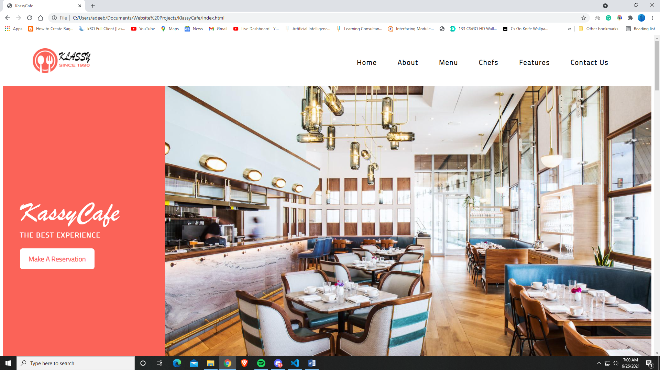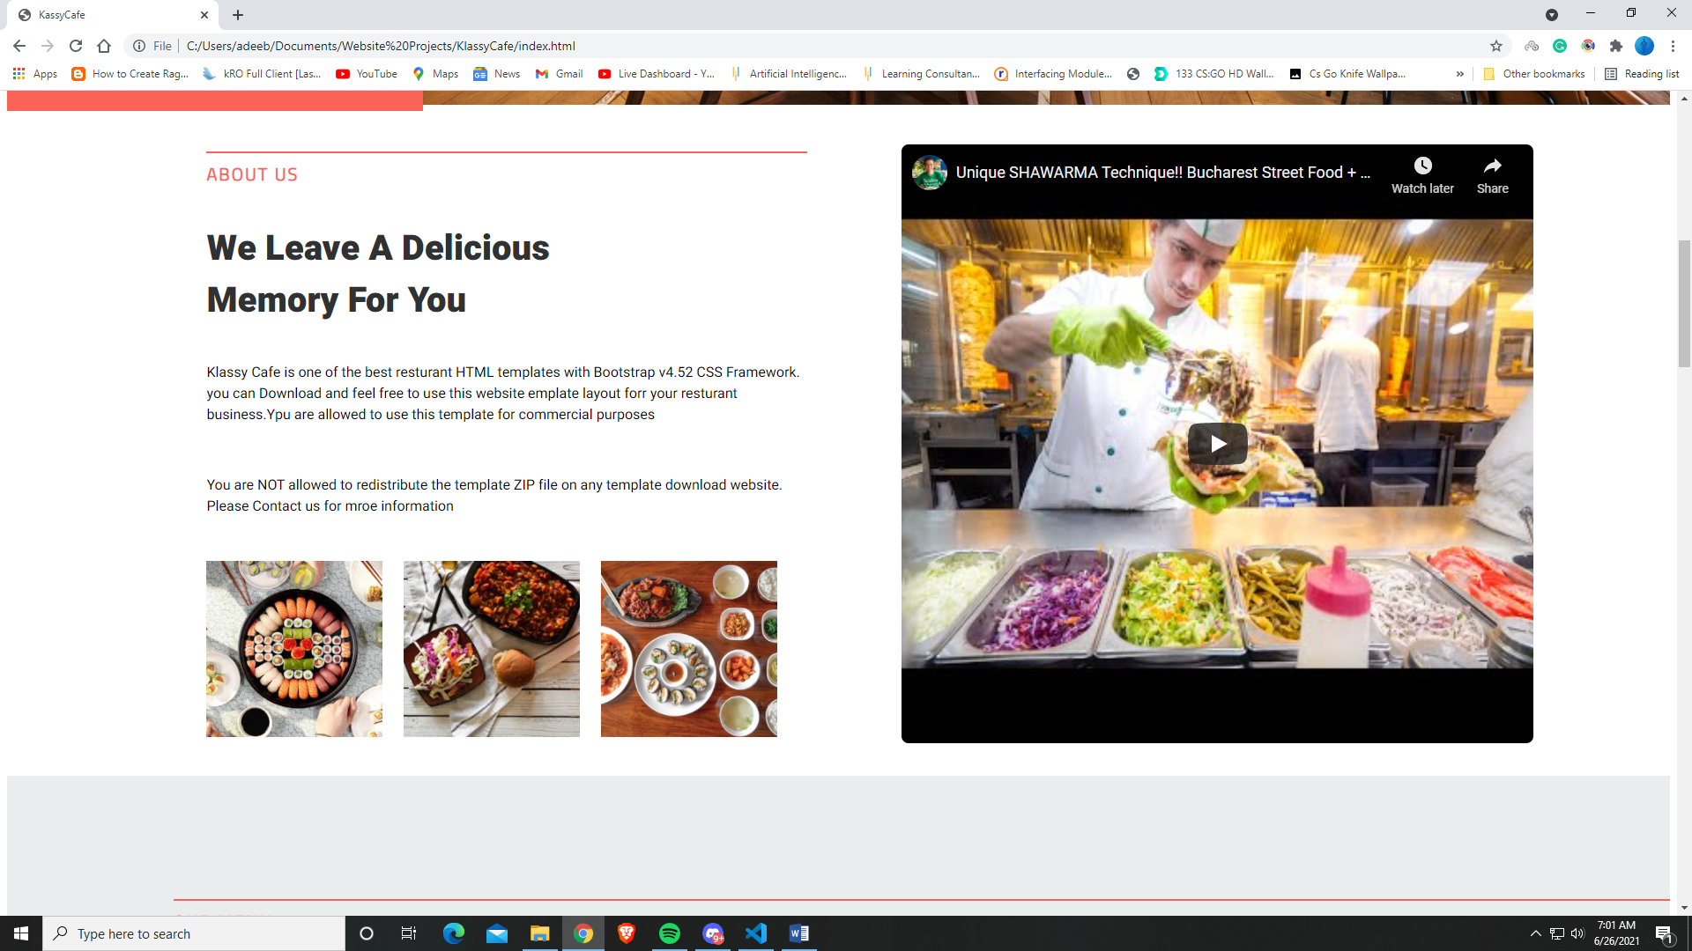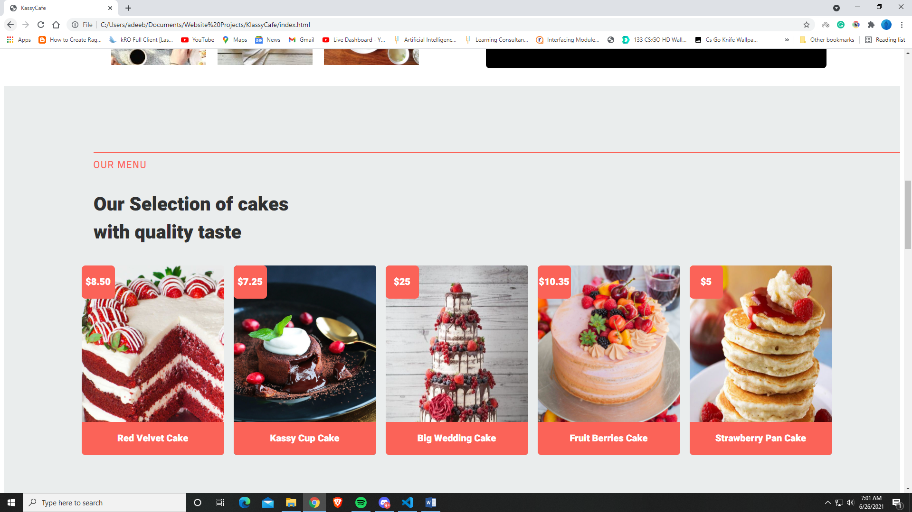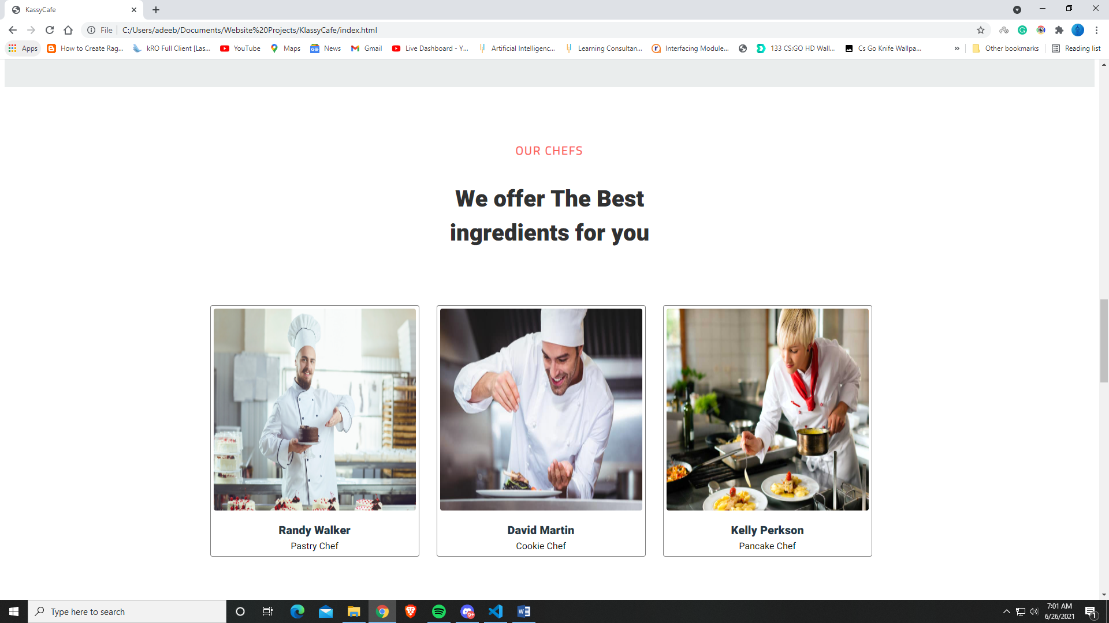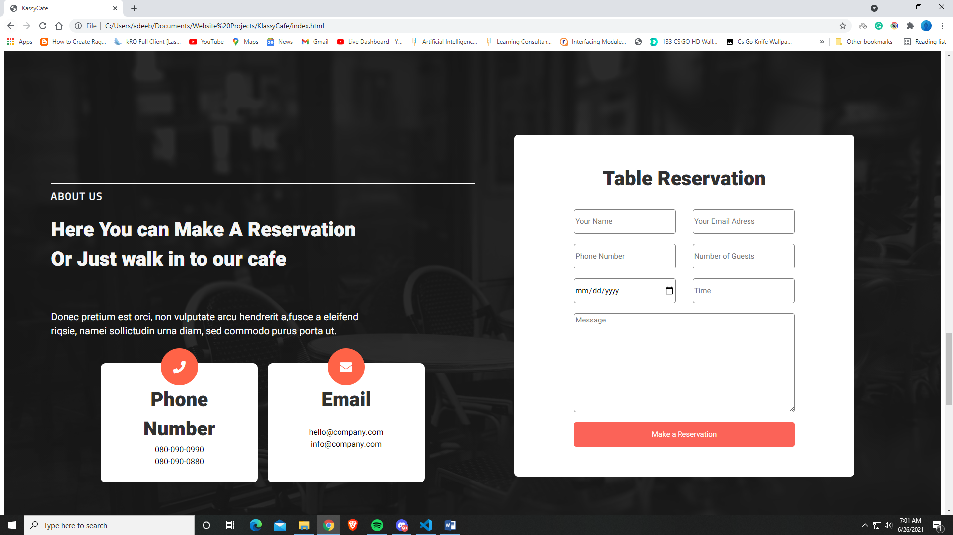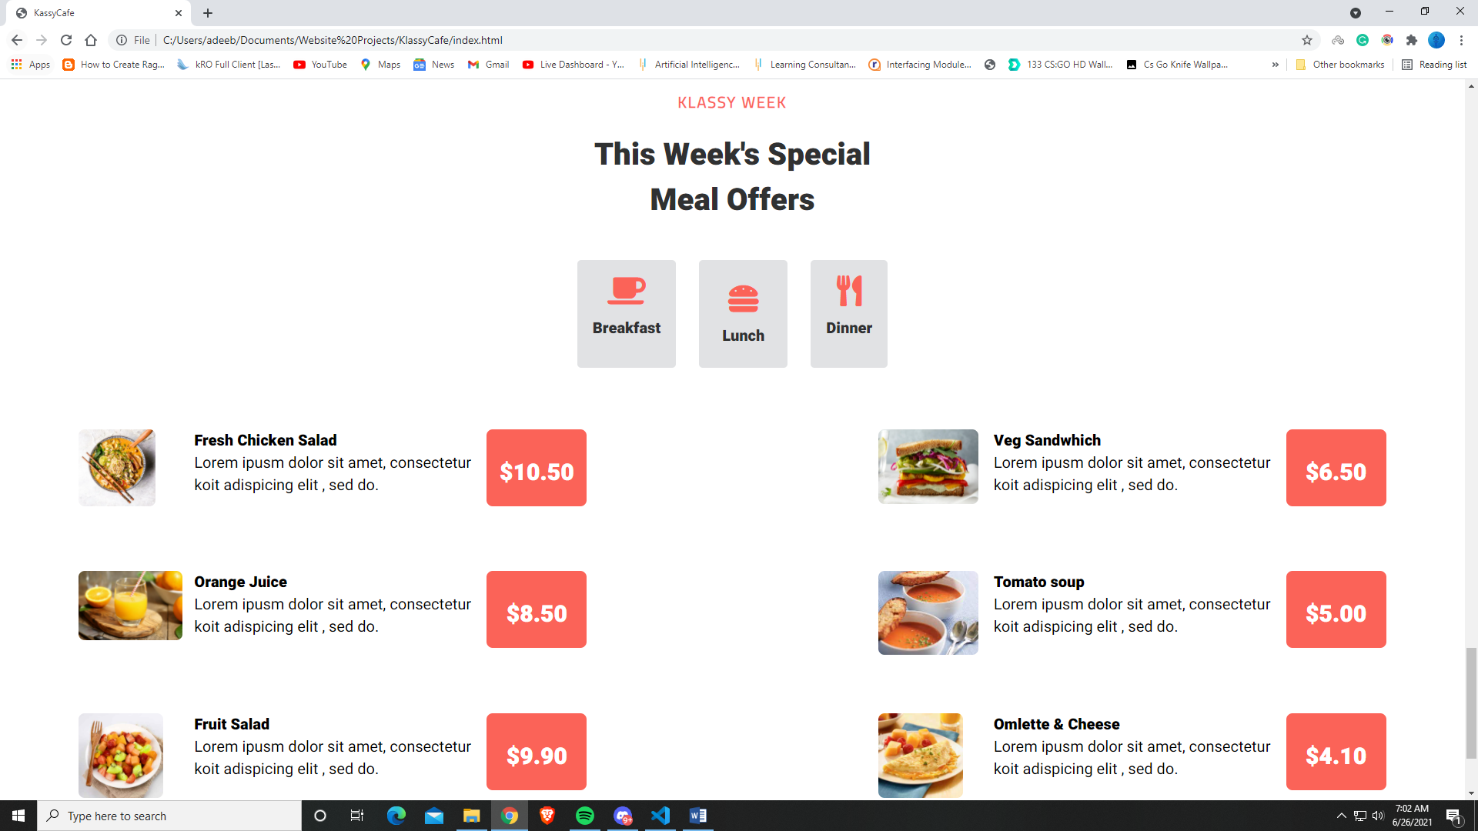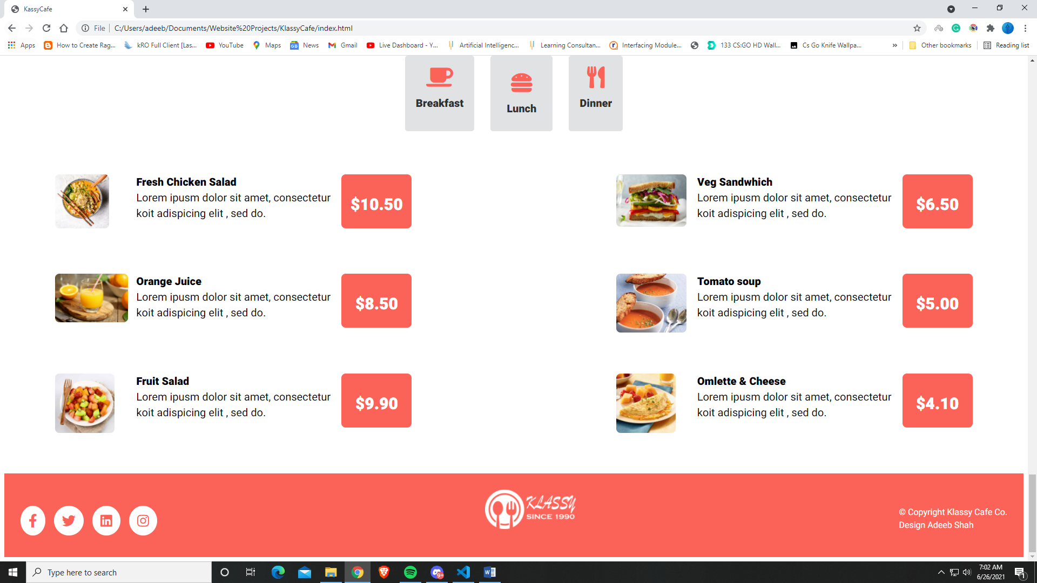

**Tablet –**

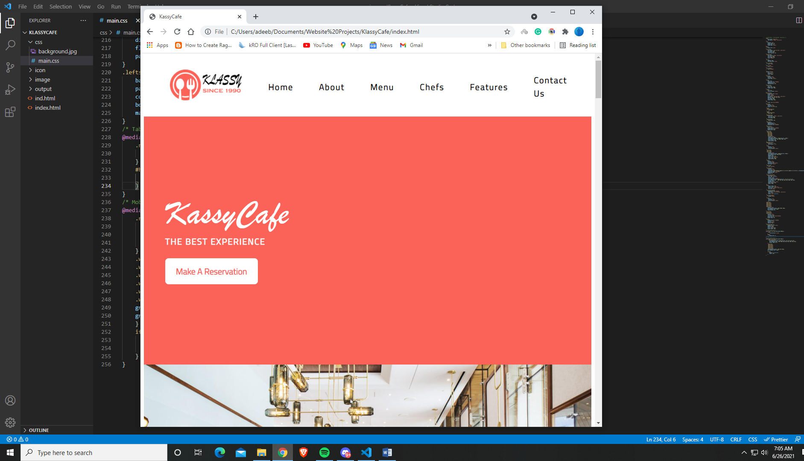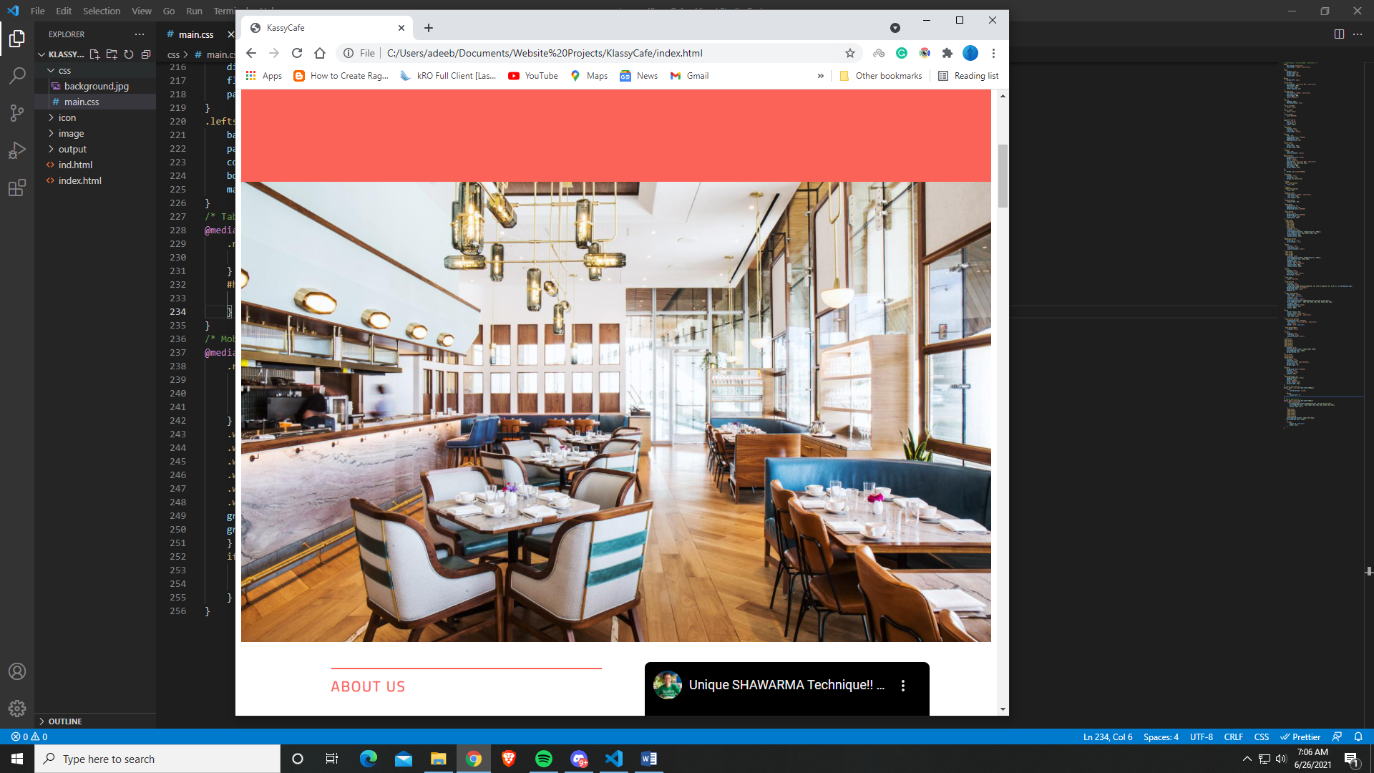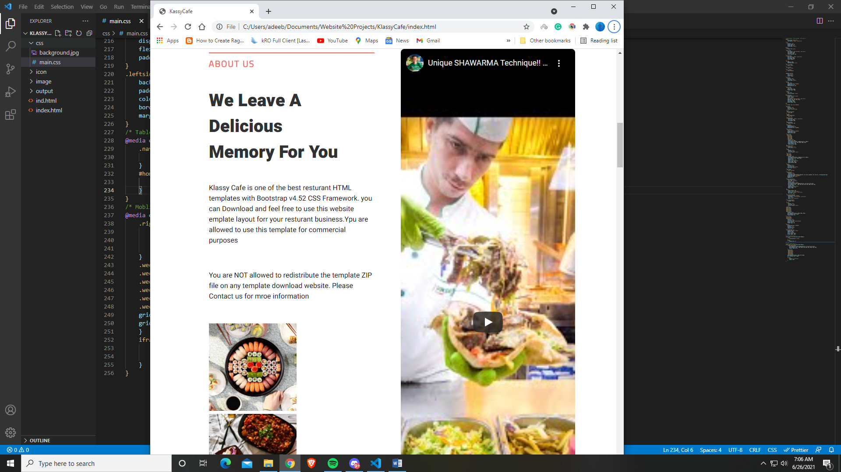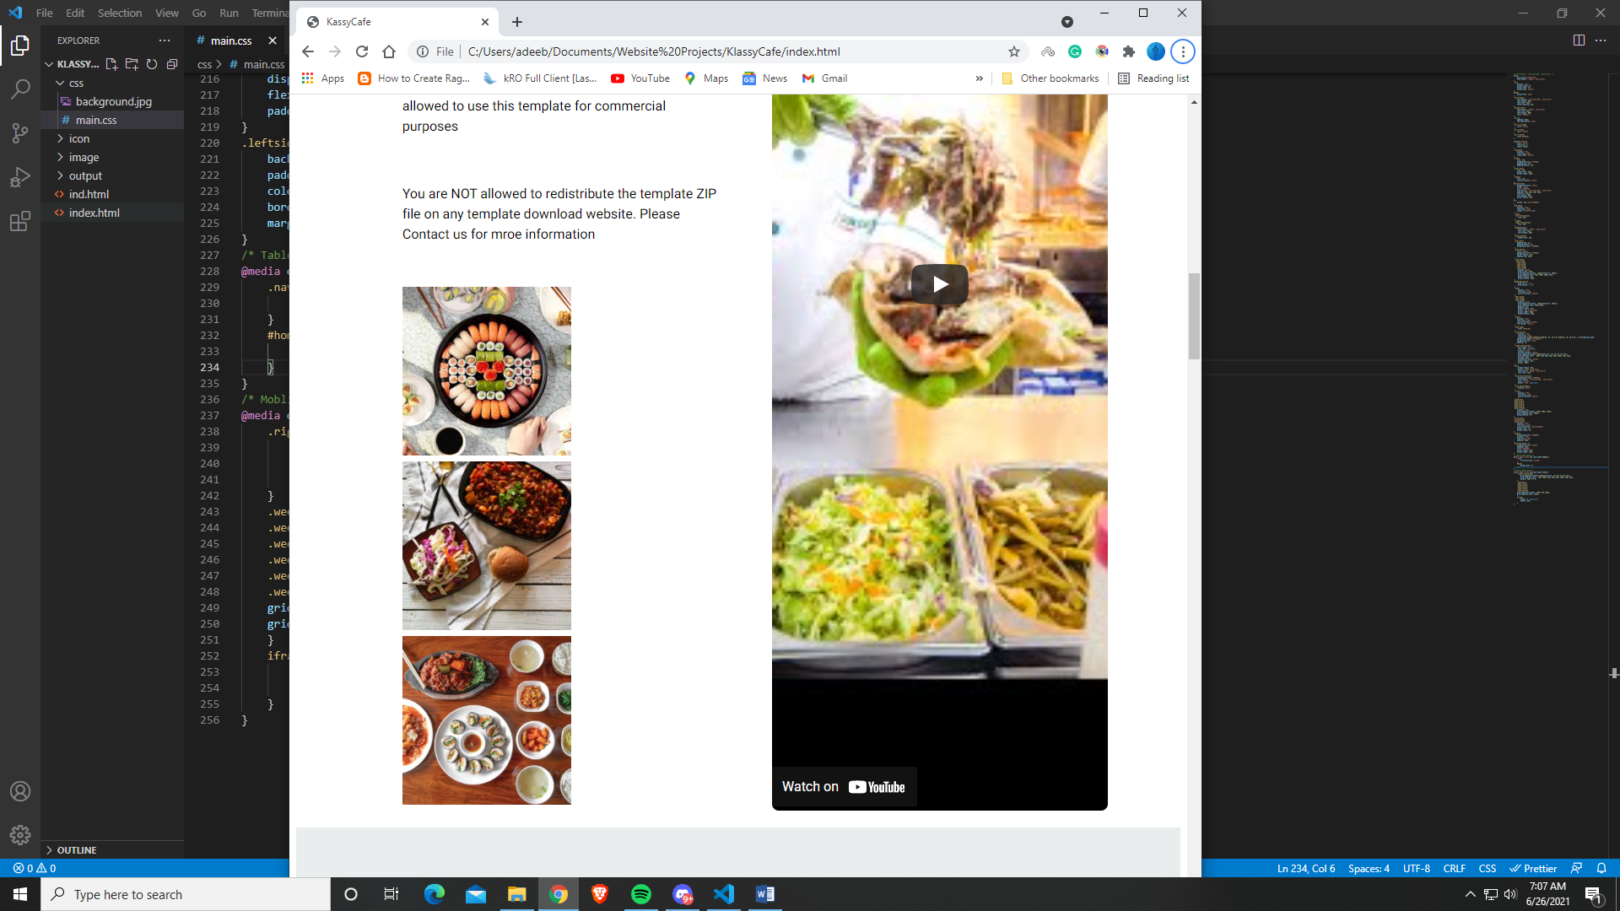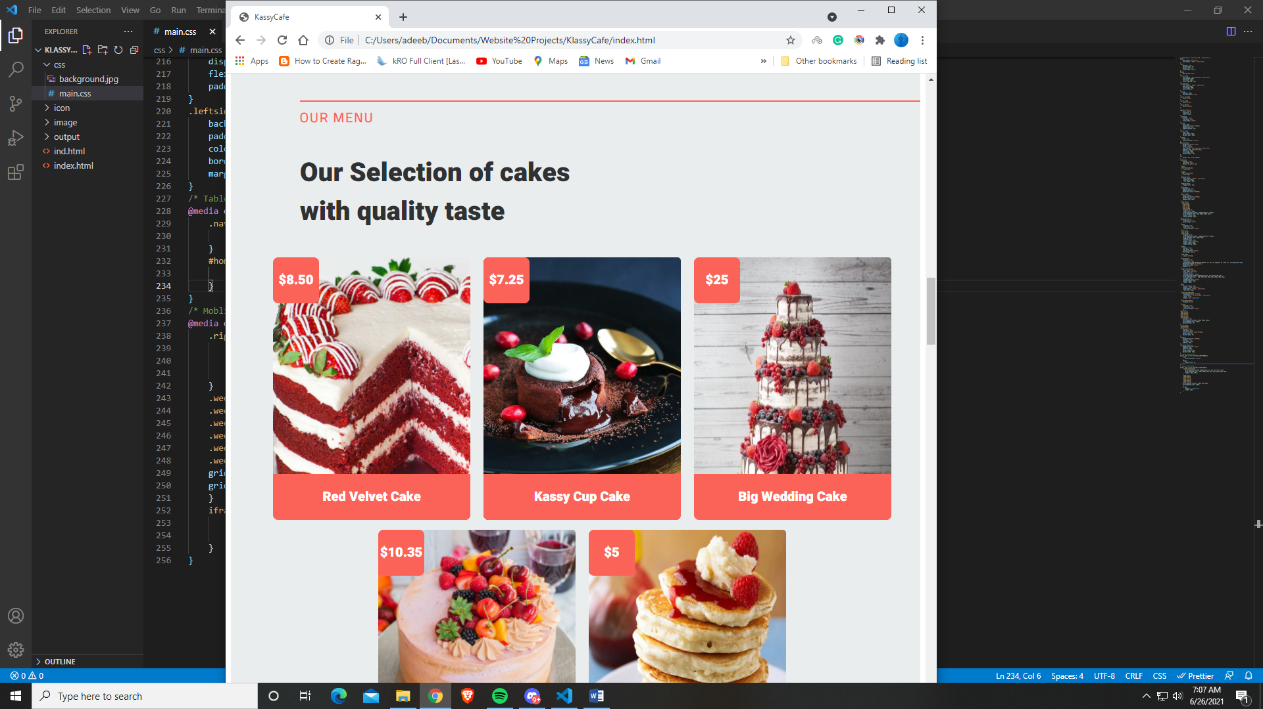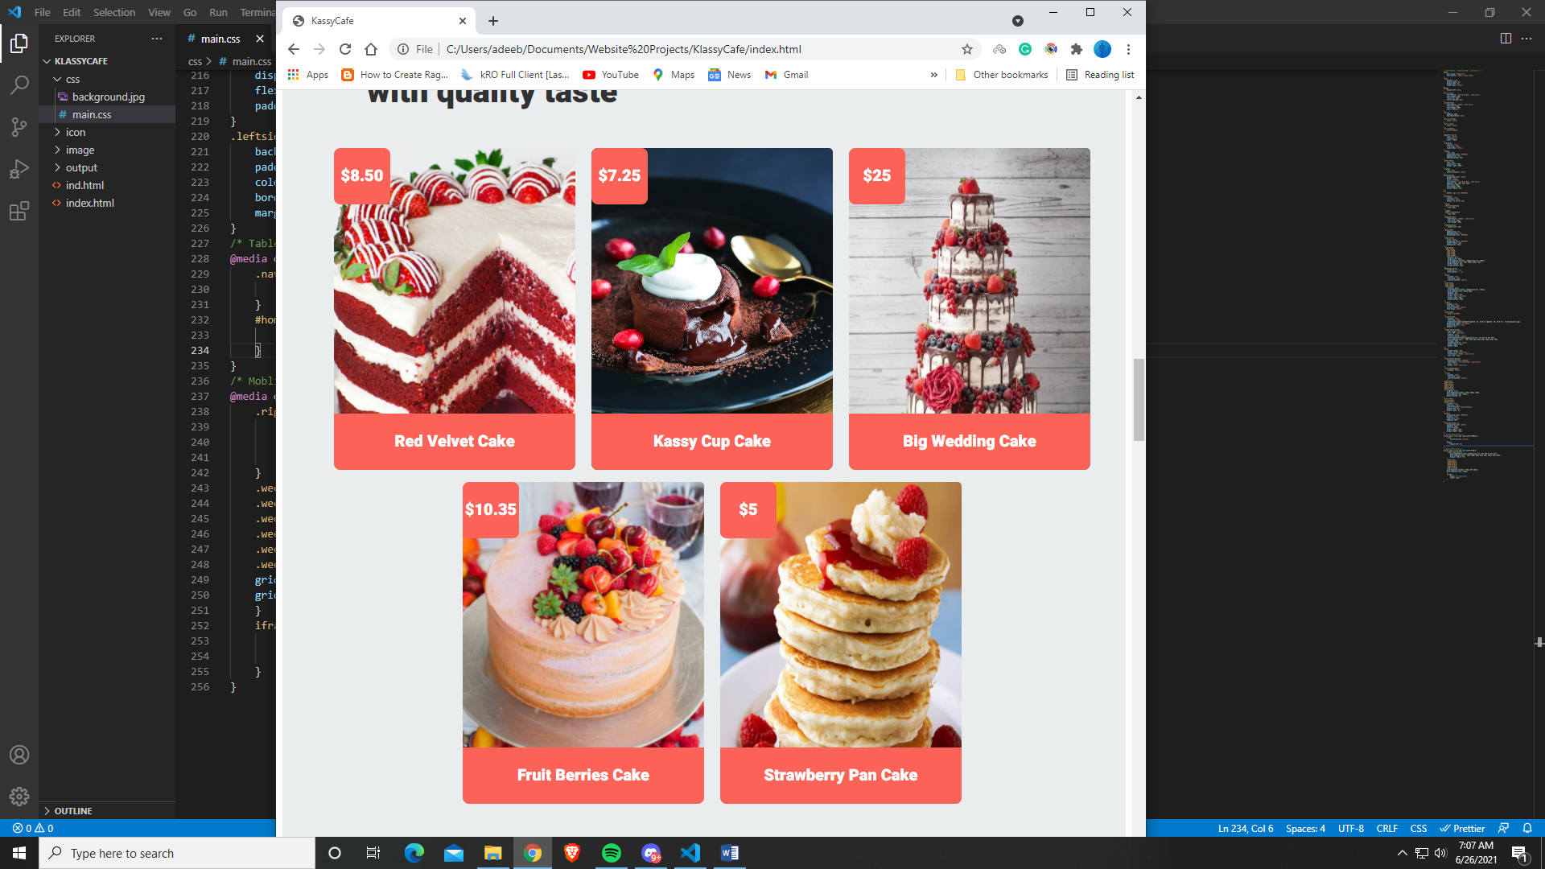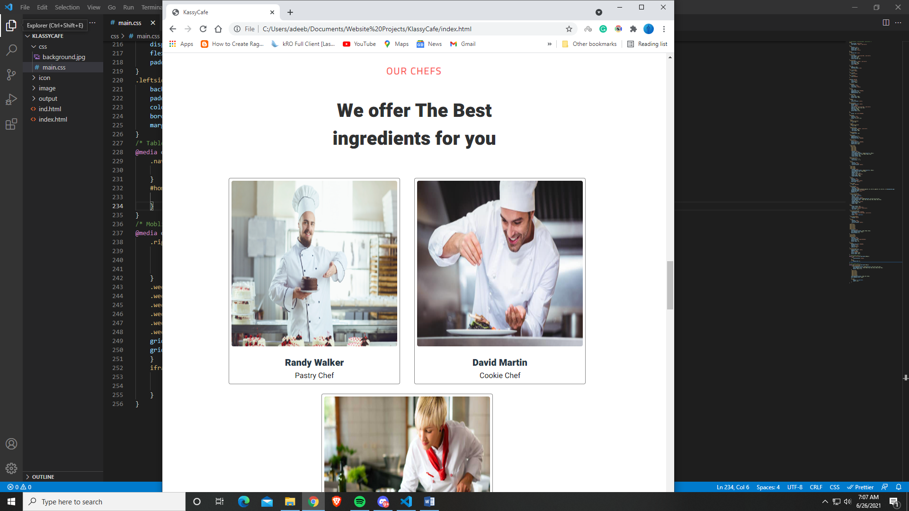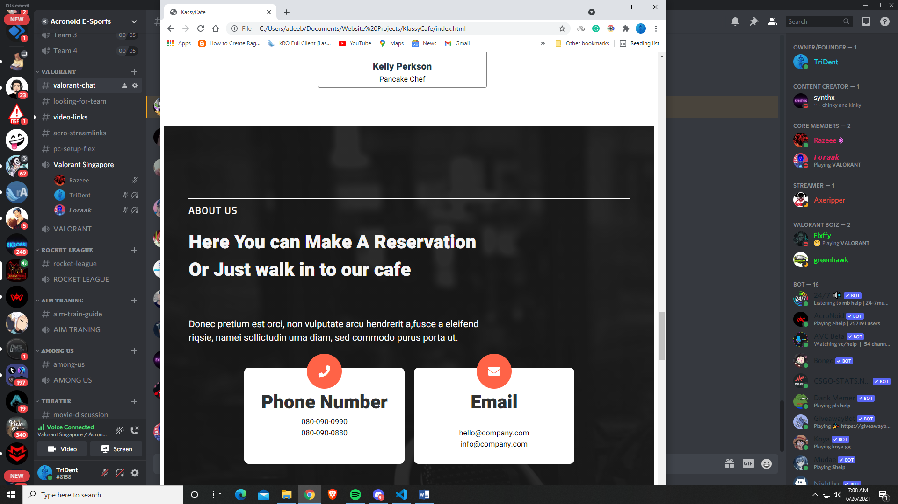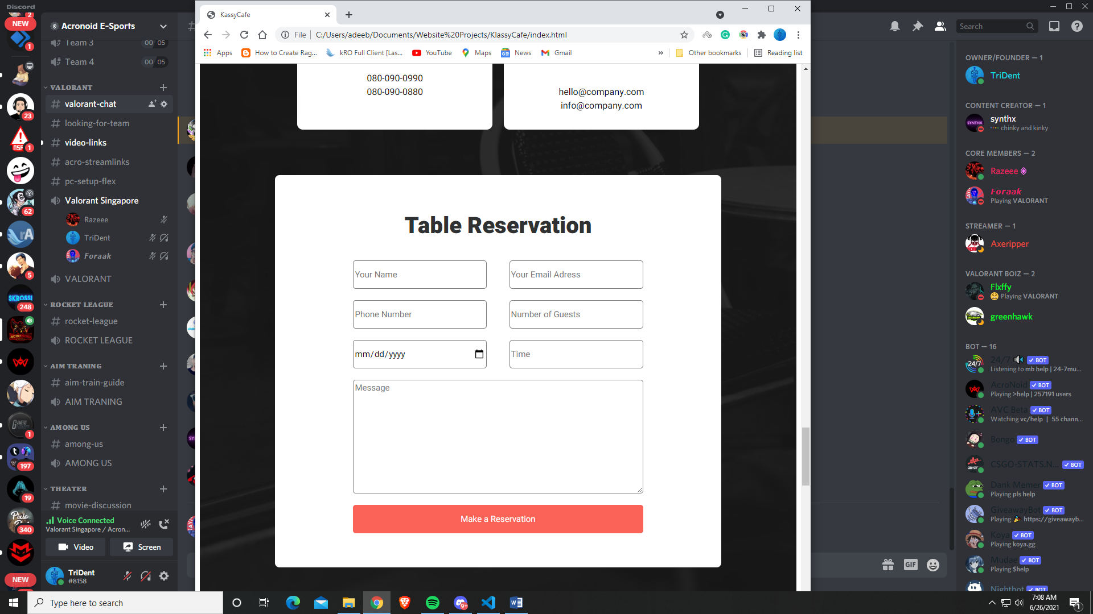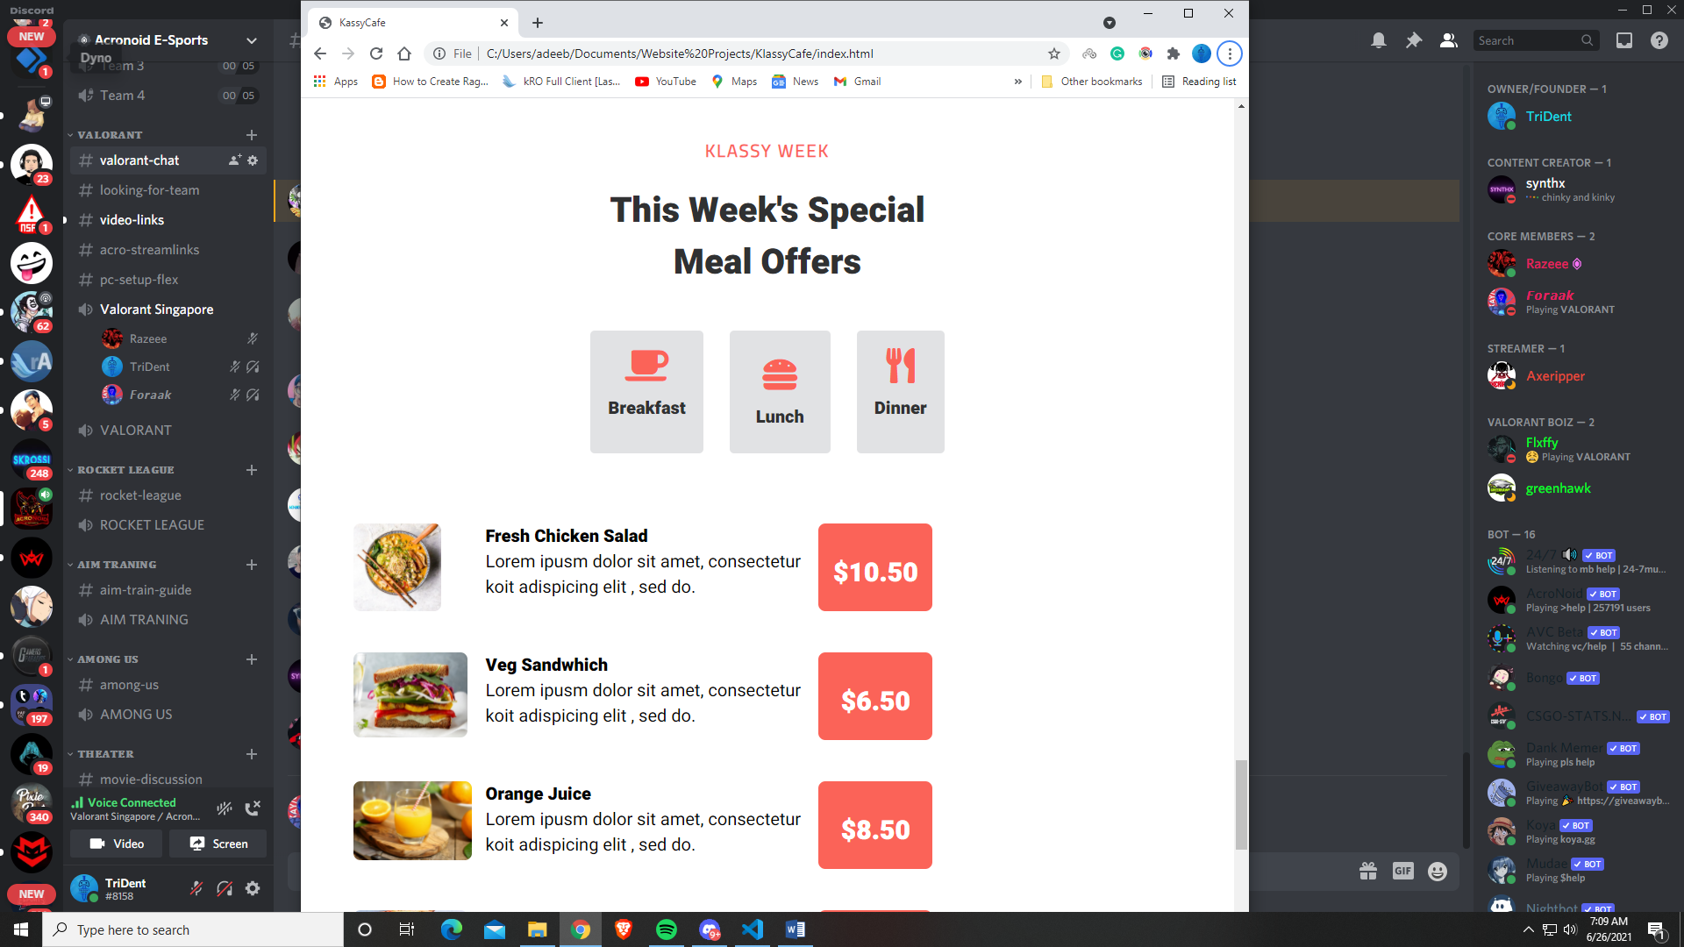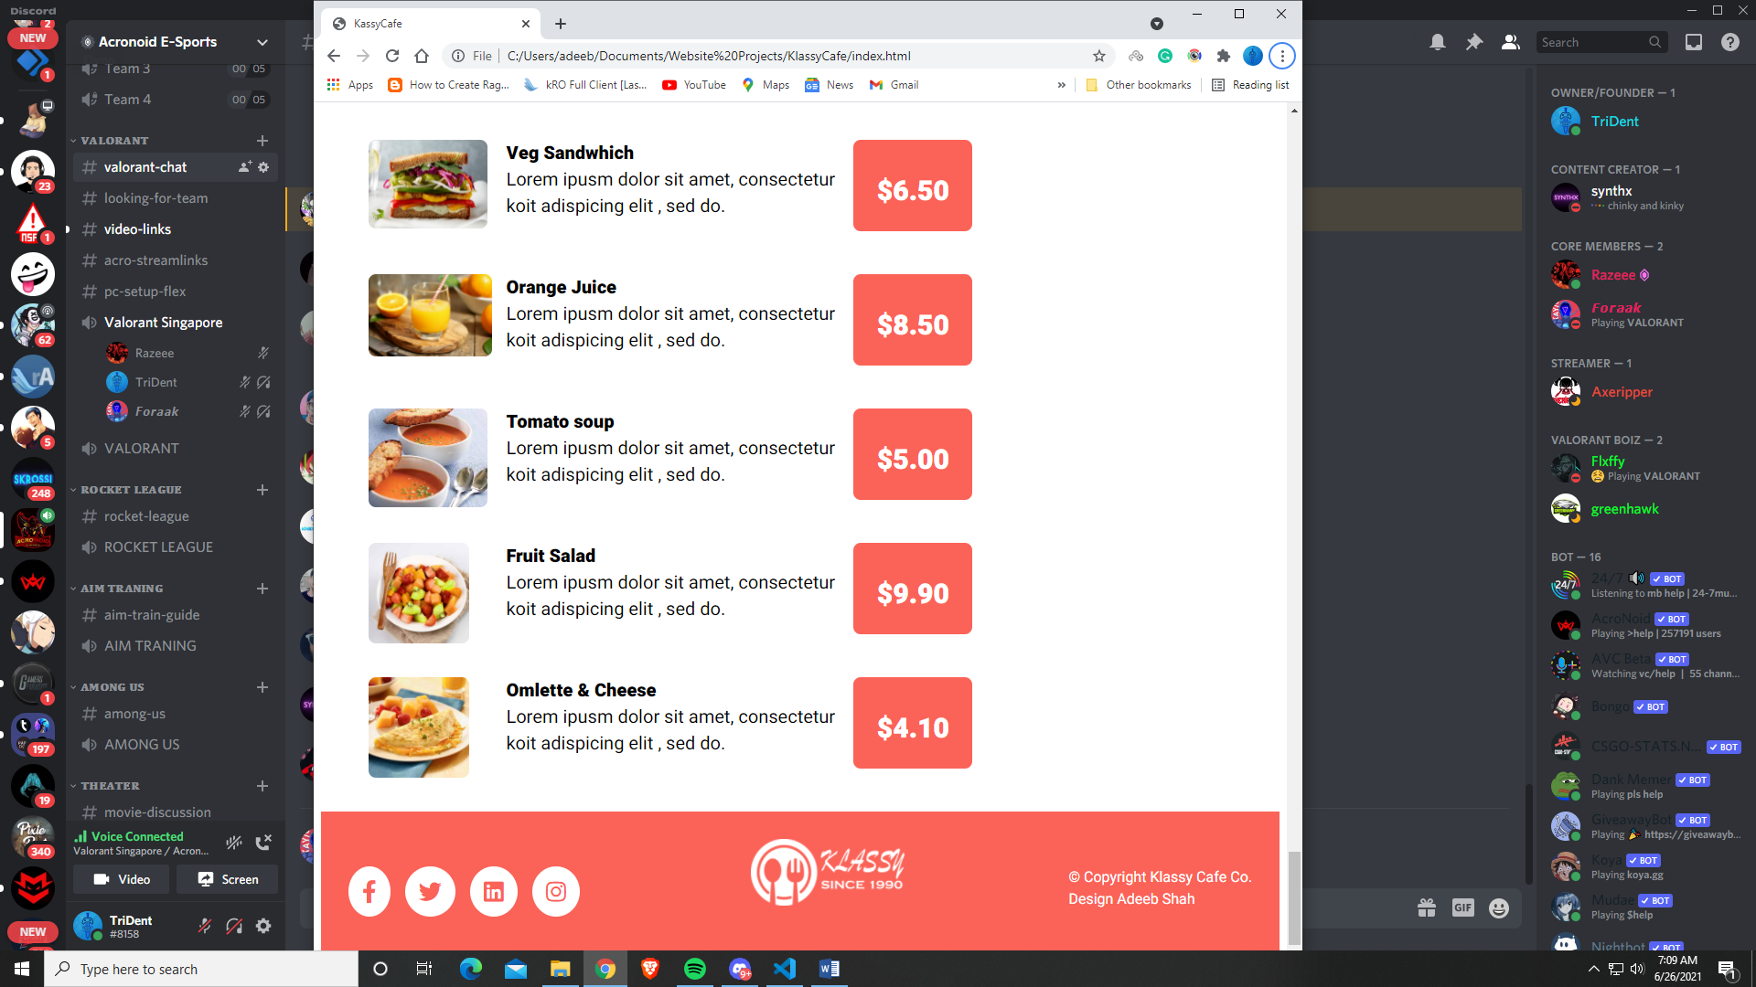

**Mobile –**

